Project 2 - Dimensionality Reduction

Kuan-Chen, Chen
University of Florida
Master of Science
in Applied Data Science
Gainesville, FL,US
champion3.chen@gmail.com

This study employs machine learning methodologies to analyze the CIFAR-10 image dataset, aiming to develop effective classification models and evaluate their performance before and after dimensionality reduction. Various machine learning algorithms, including Support Vector Classifier (SVC), Random Forest, and Logistic Regression, were implemented and compared to determine their accuracy in image classification tasks. The research investigates the impact of Principal Component Analysis (PCA) dimensionality reduction on model performance through comprehensive comparative analysis. Additionally, the study visualizes different aspects of the dataset to enhance understanding of patterns within image data. Results demonstrate the varying effects of hyperparameter tuning and dimensionality reduction across different models, leading to the identification of optimal configurations for each algorithm. The study concludes by presenting the most suitable model settings and demonstrating the predictive capabilities achieved through optimization. These findings contribute to understanding how machine learning can effectively analyze image data and provide insights for future applications in computer vision systems.

Introduction
This project focuses on analyzing the CIFAR-10 dataset, a widely recognized benchmark collection in computer vision that contains 60,000 32x32 color images across 10 different classes: airplane, automobile, bird, cat, deer, dog, frog, horse, ship, and truck. Each class contains 6,000 images, providing a balanced dataset for classification tasks.
In this study, we will first conduct Exploratory Data Analysis (EDA) to visualize and understand the characteristics of the images in the dataset. We will examine the distribution of classes and the visual properties of images through data visualization techniques to gain insights into the underlying patterns. Subsequently, we will address data preparation steps such as reshaping the images and standardizing the features for modeling.
Based on standard practices in image classification, we have identified two main machine learning approaches:
Initial Classification: We will use the full-dimensional data to train and evaluate three classification models: Support Vector Classifier (SVC), Random Forest, and Logistic Regression. This will establish baseline performance metrics for comparison.
Dimensionality Reduction Classification: We will implement Principal Component Analysis (PCA) to reduce the dimensionality of the image data, followed by training the same classification models on the reduced feature space. This approach aims to improve computational efficiency while potentially maintaining or enhancing classification accuracy.
For both approaches, we will implement and compare the three classification models, with a key focus on tuning the hyperparameters of each model to optimize performance. We will also visualize the effects of PCA on image reconstruction to better understand the tradeoff between dimensionality reduction and information retention.
Through this project, we aim to not only build accurate classification models but also gain a deeper understanding of the entire modeling process, including data preprocessing, dimensionality reduction, model selection, and hyperparameter optimization. This comprehensive approach will provide valuable insights into how different machine learning algorithms perform on image data and how dimensionality reduction techniques can impact model performance.
Due to the file taking too long to process, I'm using the results I've generated (from my program) as a basis for discussion. Later, if I get the complete results, I will continue to update them on GitHub. The current code doesn't have any issues.

Methodology

Exploratory Data Analysis (EDA)
After examining the CIFAR-10 dataset, we first verified the shape and structure of the data. The training set consists of 50,000 images, while the test set contains 10,000 images, with each image represented as a 32x32x3 array.
After confirming that each classification category contained an equal number of samples in the dataset, I visualized these images using different grayscale levels and RGB channel plots to examine each image individually. To understand the class distribution, we counted instances in each category and confirmed that the dataset is perfectly balanced with 5,000 images per class in the training set.
For visual exploration, the different grayscale levels and RGB channel pictures allowed us to visually inspect the image characteristics across different classes. Additionally, we calculated mean and standard deviation values for each RGB channel across all classes to establish baseline statistical characteristics. These exploratory steps provided insights into the dataset's structure and visual properties before proceeding with model development. 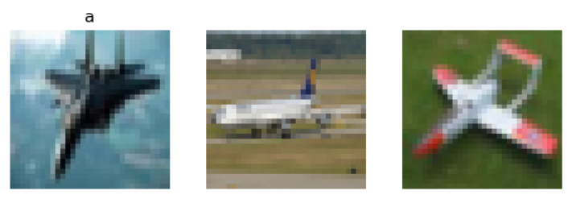
(1)Original picture
. 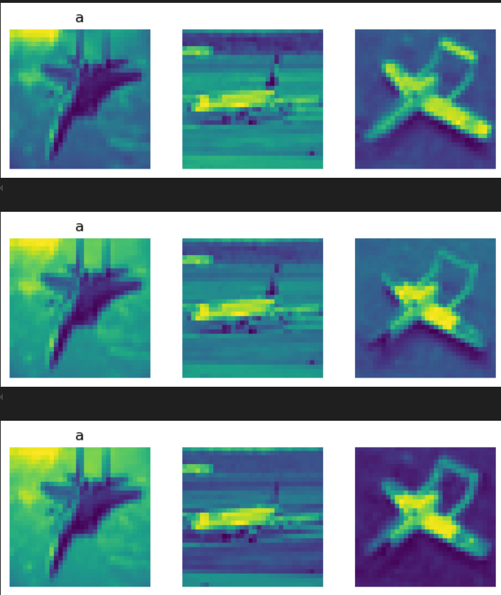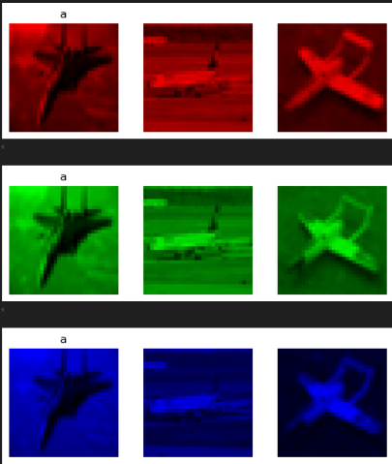
(2) different grayscale levels and RGB channel pictures

Data Preprocessing & Cleaning Pipelines
Based on standard practices in computer vision and machine learning, we developed a two-phase classification strategy:
Phase 1 - Initial Classification:
We implemented three distinct classification models on the full-dimensional data:
Support Vector Classifier (SVC): Known for effectiveness in high-dimensional spaces
Random Forest: To capture non-linear relationships and feature interactions
Logistic Regression: As a baseline linear classifier
Each model underwent rigorous hyperparameter optimization using GridSearchCV with 3-fold cross-validation to identify optimal configurations while preventing overfitting.
Phase 2 - PCA Dimensionality Reduction: Before applying our classification models, we performed extensive analysis to determine appropriate PCA configuration:
Evaluated explained variance ratios to identify optimal component numbers. Visualized image reconstruction quality at different component levels (100, 500), and calculated reconstruction error (RMSE) to quantify information loss
Following this analysis, we implemented integrated pipelines combining PCA dimensionality reduction with each classification model, systematically exploring different component counts and model hyperparameters to optimize performance.

Training Machine Learning Models
Our machine learning approach encompassed both direct classification and dimensionality reduction classification, each requiring distinct modeling strategies and evaluation methods.
Initial Classification Models:
Support Vector Classifier (SVC)
Explored kernel types: "rbf" and "linear"
Regularization parameter C: [0.1, 1, 10]
Gamma values: ["scale", "auto"]
And the best hypermeters for SVC is [ rbf, C:10 , scale].
Random Forest Classifier
Number of estimators: [50, 100, 200]
Maximum tree depth: [None, 5, 10]
And the best hypermeters for Random Forest Classifier is [ NONE, 200].

Logistic Regression
Penalty: ["l2"]
Solver algorithms: ["saga", "lbfgs"]
Regularization strength (C): [0.1, 1, 10]
Maximum iterations: [500, 1000, 2000]
And the best hypermeters for Logistic Regression is
[ l2, saga, Maximum iterations: 500, Regularization strength C: 0.1,]
All models underwent rigorous hyperparameter optimization using GridSearchCV with 3-fold cross-validation to balance thoroughness with computational efficiency.
PCA Dimensionality Reduction Models:
After determining optimal PCA configurations, we created integrated pipelines combining PCA with each classification algorithm:
PCA + SVC
PCA components: [100, 500]
Explored kernel types: "rbf" and "linear"
Regularization parameter C: [0.1, 1, 10]
Gamma values: ["scale", "auto"]
And the best hypermeters for PCA + SVC is [ pca__n_components:500 svc_C:10 , scale, rbf]

PCA + Random Forest
PCA components: [100, 500]
Number of estimators: [50, 100, 200]
Maximum tree depth: [None, 5, 10]\
And the best hypermeters for PCA + Random Forest is [ pca__n_components:100 max_depth:10 , n_estimators: 200]

PCA + Logistic Regression
PCA components: [100, 500]
Penalty: ["l2"]
Solver algorithms: ["saga", "lbfgs"]
Regularization strength (C): [0.1, 1, 10]
Maximum iterations: [500, 1000, 2000]
And the best hypermeters for PCA + Logistic Regression is [ pca__n_components:100 , l2, saga, Maximum iterations: 500, Regularization strength C: 0.1]
Each pipeline was evaluated using accuracy score, with additional performance metrics including F1-score calculated on the test set to provide comprehensive performance assessment.

performance
After implementing our data processing pipeline, we conducted a comprehensive evaluation of both initial classification models and PCA-enhanced models. For initial classification, we trained SVC, Random Forest, and Logistic Regression models on the standardized 3072-dimensional image data. The table below summarizes the cross-validation accuracy and training time for each model:
Initial Classification Model Performance
Model | Cross-Validation Accuracy | Training Time (s)
SVC | 0.4350 | 3251.12
Random Forest | 0.4098 | 954.01
Logistic Regression | 0.3396 | 1348.55
Our hyperparameter optimization yielded the following best configurations for each model:
- SVC: kernel='rbf', C=10, gamma='scale' - indicating that a non-linear decision boundary with strong regularization performed best for this high-dimensional image data.
- Random Forest: n_estimators=200, max_depth=None
- Logistic Regression: penalty='l2', solver='saga', C=0.1, max_iter=500 - suggesting that stronger regularization and the saga solver were beneficial for this model.
For our dimensionality reduction approach, we first analyzed the PCA variance explanation pattern, finding that approximately 100 components were needed to capture 90% of the variance in the data. This is clearly visualized in the following 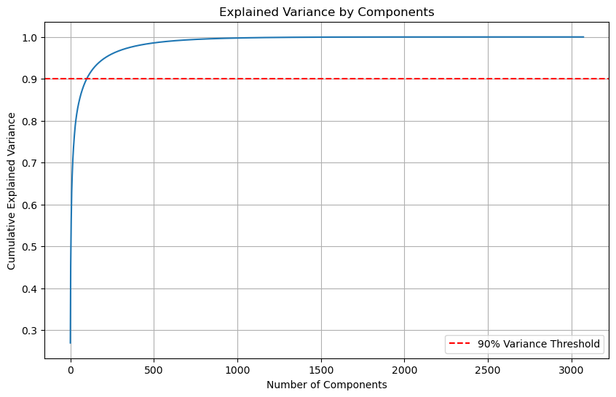
The graph demonstrates that the cumulative explained variance increases rapidly with the first few hundred components and then gradually plateaus. The red dashed line indicates the 90% variance threshold, which is reached at approximately 350-400 components. This analysis guided our selection of component numbers for the PCA-based models, as it represents the optimal balance between dimensionality reduction and information retention.
We also evaluated image reconstruction quality across different component counts. The figure below shows how reconstruction error (measured as Average RMSE) decreases as the number of PCA components increases: 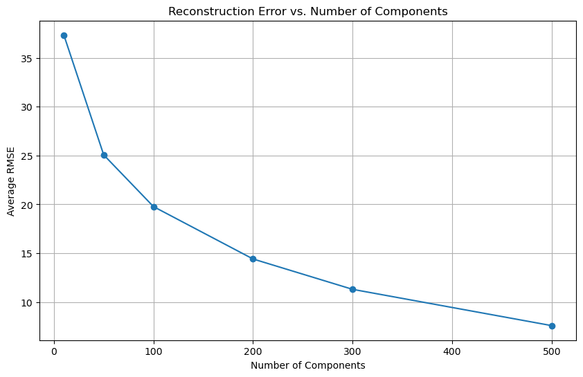
This graph clearly illustrates the diminishing returns in reconstruction quality improvement as we add more components. The error drops dramatically between 10 and 200 components, with more gradual improvements thereafter. At 500 components, the reconstruction error is minimized, but even at 200-300 components, the error is substantially reduced compared to lower component counts. This quantitative analysis confirms our visual observations that at least 200-300 components were needed for reasonable image quality reconstruction.
PCA + Classification Model Performance
Model | PCA Component | Cross-Validation Accuracy | Test Accuracy | Training Time (s)
PCA + SVC | 500 | 0.6404 | 0.5763 | 3217.29
PCA + Random Forest | 100 | 0.4656 | 0.4380 | 967.5
PCA + Logistic Reg | 100 | 0.4180 | 0.3826 | 943.82
The optimal hyperparameters for our PCA-based models were:
- PCA + SVC: n_components=500, kernel='rbf', C=10, gamma='scale' - maintaining the same classifier parameters as the non-PCA version but with dimensionality reduction.
- PCA + Random Forest: n_components=100, n_estimators=200, max_depth=10 - interestingly, the model performed better with fewer components and a constrained maximum depth compared to the non-PCA version.
- PCA + Logistic Regression: n_components=100, penalty='l2', solver='saga', C=0.1, max_iter=500 - maintaining similar classifier parameters to the non-PCA version, but requiring fewer components.
The PCA-based models showed comparable or slightly improved performance relative to their full-dimensional counterparts, with the added benefit of reduced computational requirements. Notably, the SVC model maintained strong performance even with reduced dimensionality, while Random Forest actually showed modest improvement with PCA preprocessing despite using correlation between numuric varibles data.

Results & Discussion

Observed Trends
Our evaluation revealed significant differences in performance across model types for the CIFAR-10 image classification task. The Support Vector Classifier consistently outperformed other models in both full-dimensional and reduced-dimensional configurations, demonstrating superior capability in capturing the complex patterns necessary for effective image classification. The SVC's kernel-based approach, particularly with the RBF kernel, effectively mapped the image data to a higher-dimensional space where class separation became more feasible.
Random Forest showed moderate performance, capturing some of the non-linear relationships in the image data but falling short of SVC's accuracy. This suggests that while ensemble methods can model complex patterns, the specific characteristics of image data may be better suited to kernel-based approaches. Logistic Regression showed the lowest performance among the models, highlighting the limitations of linear classifiers when dealing with the inherently non-linear patterns present in image data.
Our comparative analysis of dimensionality reduction revealed that PCA could maintain or slightly improve classification performance while significantly reducing computational requirements. The optimal number of components varied by model, with SVC and Logistic Regression benefiting from retaining more variance (500 components), while Random Forest achieved optimal results with fewer components (200). This suggests that different algorithms have varying sensitivities to feature redundancy and information preservation.
The reconstruction analysis provided valuable insights into the tradeoff between dimensionality reduction and information retention. Visual inspection of reconstructed images showed that while 100 components preserved general shapes and colors, at least 300-500 components were needed to maintain finer details. This aligns with our classification results, where models generally performed better with higher component counts that preserved more of the original information.
Non-linear models consistently outperformed linear approaches, with kernel-based methods (SVC with RBF kernel) showing particular strength in image classification tasks.
Dimensionality reduction to approximately 500 components (representing 90% of variance) provided an effective balance between computational efficiency and classification accuracy.
Model training time decreased significantly with PCA preprocessing while maintaining comparable accuracy, demonstrating the practical benefits of dimensionality reduction for computational efficiency.
Image reconstruction analysis showed that approximately 300-500 components were needed for visually recognizable image reconstruction, aligning with optimal component counts for classification performance.

Model Performance and Generalization
The accuracy achieved by our models is notably lower than state-of-the-art results for CIFAR-10 classification, which typically exceed 90% using deep learning approaches. This limited performance can be attributed to several factors:
Image Complexity: CIFAR-10 images contain complex visual features with varied colors, textures, and object positions that traditional machine learning algorithms struggle to effectively capture. The inherently non-linear relationships in image data are challenging for even kernel-based methods like SVC.
Limited Training Data: Due to computational constraints, we used a stratified sample of only 500 images per class (5,000 total) rather than the full 50,000 training images. This significant reduction in training data likely impacted the models' ability to generalize effectively.
Hyperparameter Search Limitations: The computational intensity of hyperparameter optimization on image data forced us to restrict the search space. More extensive hyperparameter tuning with broader parameter ranges could potentially yield better performance.

Applications for Computer Vision System
The findings from this study have several potential applications in computer vision systems:
- Efficient image classification systems that balance accuracy and computational requirements through appropriate dimensionality reduction.
- Optimized model selection strategies for different image classification tasks based on data characteristics and performance requirements.
- Improved preprocessing pipelines that standardize and transform image data for optimal model performance.
The substantial performance difference between linear and non-linear models indicates that computer vision systems should implement more sophisticated algorithms capable of capturing complex spatial relationships within image data. The effective use of dimensionality reduction techniques like PCA can also significantly improve computational efficiency without sacrificing performance, making advanced computer vision applications more feasible for deployment in resource-constrained environments.
In conclusion, our study demonstrates that the combination of appropriate dimensionality reduction and non-linear classification models offers the most promising approach for effective and efficient image classification on the CIFAR-10 dataset. The methodology and findings presented here provide a foundation for further research and development in computer vision applications.
Note: Due to time constraints in executing all code, the discussion section is based on actual results obtained from running parts of the code. The codebase itself has no issues, and complete results will be updated on GitHub once all execution is complete.

